Create [login and registration form](https://www.google.bg/url?sa=t&rct=j&q=&esrc=s&source=web&cd=1&cad=rja&uact=8&ved=0ahUKEwiDjL_-yvnVAhVD5xoKHbrLDcEQFgglMAA&url=https%3A%2F%2Ftympanus.net%2Fcodrops%2F2012%2F03%2F27%2Flogin-and-registration-form-with-html5-and-css3%2F&usg=AFQjCNFbBSYW42HXrt8w4xqvwyE20cIX_w)

1.

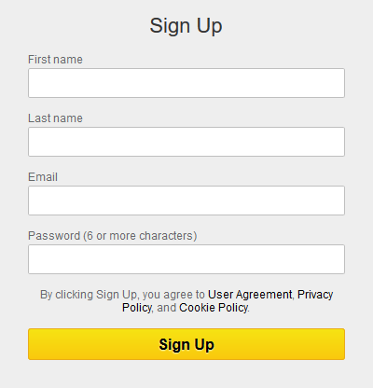

2.

C:\Users\LegalTrek\Downloads\sign_in_form.png

Create a PHP / MySQL /JavaScript app simple login/register functionality and list in table all registered users.

* Make simple registration form with HTML and CSS. Check the first screenshot and try to make it similar.
* When submit the form take all information from the form and make new record in the 'users' in your DB.
* When saving in the DB is done just show alert with text "Registration successful!”
* Make simple login form. Check second screenshot.
* On submit check if the user exist in the DB and his password is correct.
* If email and password are correct, just show list with all registered users
* If email is not in the DB or password is not correct, show alert for incorrect email or password.
* In the table with registered users put, delete button for each of them.
* On click delete, this user must be removed from the DB.

Bonus points:

* \*OOP code
* Make good-looking users table.
* Use different file for the CSS.
* \*Try using Ajax for deleting request.
* \*Use sessions for logged user.
* \*Make GitHub repository for the task and commit all changes in it.

\* - tasks with increased difficulty!

If you have any questions do not hesitate to ask. Good luck and have fun!